**Treadwell, Sophie (1885-1970)**

Like many women writers of her day, American playwright Sophie Treadwell began her career in journalism, working at the *San Francisco* *Bulletin* and the *New York Herald Tribune*, where she wrote fanciful vignettes before earning the right to cover sensational murder trials of female defendants and to report from behind the front lines of war (including an interview with Mexican revolutionary Pancho Villa). These assignments appear to have imprinted her dramatic style, which often tempered realistic situations with surreal, sometimes violent, imagery; a well-made play structure with an episodic logic; and the predictability of a character type with an unexpected act of rebellion.

Treadwell, who wrote over forty plays (seven of which were produced on Broadway), is best-known for *Machinal* (1928), an expressionist drama about a ‘young woman’ who is coercively compelled to enact the roles of secretary, daughter, wife, and mother over the short course of her doomed life. Only in an illicit love affair does she find true happiness, taking inspiration from her lover’s tales of renegade justice in Mexico to free herself from her oppressive marriage by killing her husband. But her freedom is short-lived, as the social order hails her back into its defining structures. After being forced to fit the pre-set narratives of a sensationalistic press, her life is condemned by the law before finally being taken from her by way of the electric chair.

*For Saxophone* (1934) similarly treats the life of a young woman, Lily, whose engagement, wedding, honeymoon and marriage are choreographed for her in a dance of self-negation. Faced with three impossibilities—escaping with her lover, a Russian knife thrower (and literally running away with the circus), returning to her wealthy husband (and back to a pampered state of non-existence), or pursuing a life of independence (but only as prescribed by a charismatic psychotherapeutic writer)—Lily discovers that she has no real choice. Her life ends in grand guignol fashion, when she is killed by her lover, who accidentally—and symbolically—cuts her into the psychological pieces that she has been unable to integrate into a unified self-authored identity. As in *Machinal*, experimental lighting, symbolic music, disembodied voices, and mute presences mark the play’s expressionistic style.

Treadwell’s dystopian vision posed an almost insurmountable challenge to most theatrical producers. Although *Machinal* proved a commercial success on Broadway, contemporary critics dismissed it for simply exploiting popular interest in the recent Ruth Snyder-Judd Gray murder trial; they further denied her creativity by misattributing the play’s experimental form to producer Arthur Hopkins. *For Saxophone* remained unproduced during Treadwell’s lifetime, despite scene designer Robert Edmond Jones’s sustained enthusiasm for the project.

Not until the 1980s, when feminist literary critics and theatre historians recuperated Treadwell’s work, did it begin to receive significant critical attention. Their focus on her plays’ implicit critique of patriarchy allowed for a renewed assessment of their artistic value. More recent studies have examined Treadwell’s plays in relation to contemporary modernist experimentation, such as her work with Richard Boleslavsky, the Russian émigré whose American Lab Theatre trained actors in using movement to illustrate the rhythms, speed, and pulse of modernization (Dickey 2003); and her engagement with expressionism, staging ‘characters in the background heard, but unseen,’ and ‘characters in the background seen, not heard’ (*Machinal* in Gassner 496) in order to suggest the dissociation of sensibility brought about by modern inventions such as silent film, the typewriter, telephone, phonograph and radio (Walker 2005).

**List of Works**

Treadwell, Sophie. (2006) *Broadway’s Bravest Woman: Selected Writings of Sophie Treadwell*, ed. Jerry Dickey and Miriam López-Rodríguez, Carbondale: Southern Illinois University Press.

----- (1949) *Machinal*, in *Twenty-Five Best Plays of the Modern American Theatre*, ed. John Gassner, New York: Crown Publishers.

Papers of Sophie Treadwell, University of Arizona, University Libraries, Special Collections, <http://speccoll.library.arizona.edu/collections/papers-sophie-treadwell>. This archive includes many plays and novels by Treadwell, including *For Saxophone* (1934).

**References and Further Reading**

Dickey, Jerry R. (1999) ‘The “Real Lives” of Sophie Treadwell: Expressionism and the Feminist Aesthetic in *Machinal* and *For Saxophone*,’ *Speaking the Other Self: American Women Writers*, ed. Jeanne Campbell Reesman, Athens: University of Georgia Press. 176-84.

----- (1999) “The Expressionist Moment: Sophie Treadwell,” *The*  *Cambridge Companion to American Women Playwrights*, ed. Brenda Murphy, New York: Cambridge University Press, 66-81.

----- (1997) *Sophie Treadwell: A Research and Production Sourcebook*, Westport, CT: Greenwood.

----- (2003) ‘Sophie Treadwell’s Summer with Boleslavsky and Lectures for the American Laboratory Theatre,’ *Experimenters, Rebels and Disparate Voices: The Theatre of the 1920s Celebrates American Diversity*, ed. Arthur Gewirtz and James J. Kolb, Westport, CT: Greenwood.

Ozieblo, Barbara, and Jerry R. Dickey. (2008) *Susan Glaspell and Sophie Treadwell*, London: Routledge.

Walker, Julia A. (2005) *Expressionism and Modernism in the American Theatre: Bodies, Voices, Words*, Cambridge: Cambridge University Press.

**Julia A. Walker, Washington University in St. Louis**

**Recommended Illustrations**

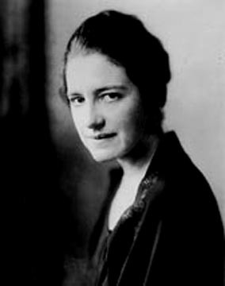

**Sophie Treadwell, circa 1925.**

[Photo by Bachrach; available at University of Arizona Library Special, MS 318, Box 21, folder 10 in UA Special Collections); Collections: <http://www.library.arizona.edu/exhibits/treadwell/> ]

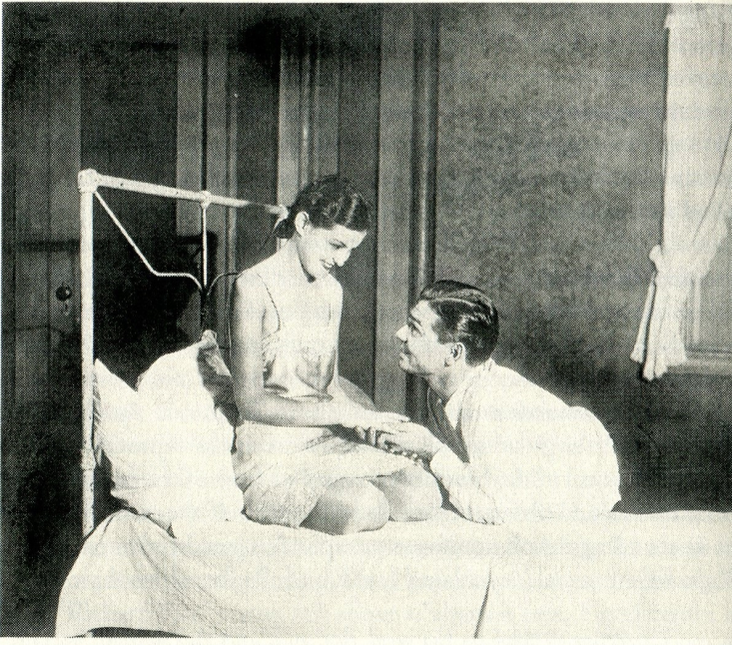

**Zita Johann and Clark Gable in episode six, ‘Intimate,’ in the 1928 Broadway production of *Machinal*.**

[Billy Rose Performing Arts Collection at the New York Public Library, Astor, Lennox and Tilden Foundations.]